# MAP Reduce

## EMR Hadoop cluster creation and to run hive queries

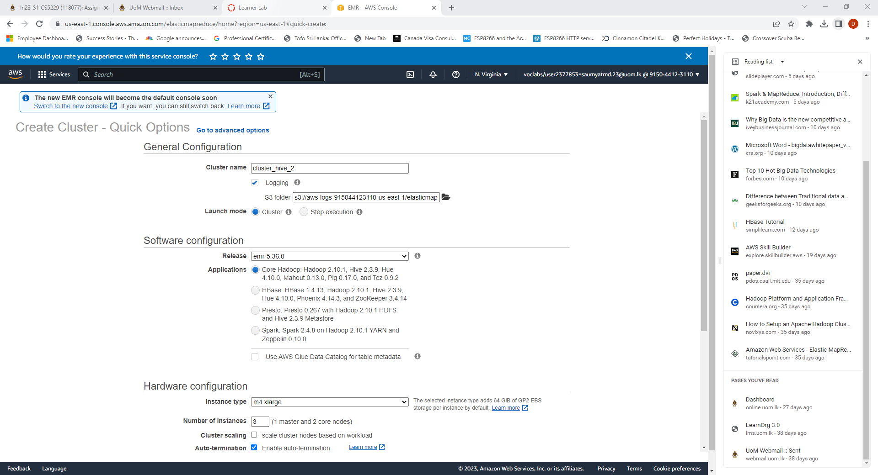

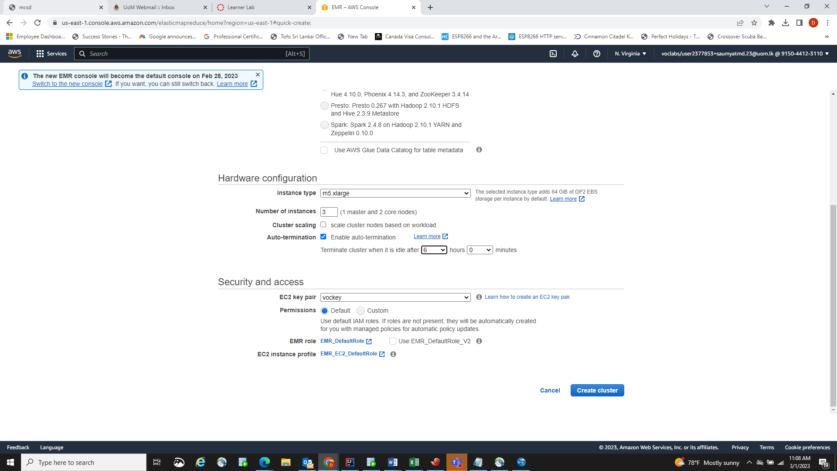

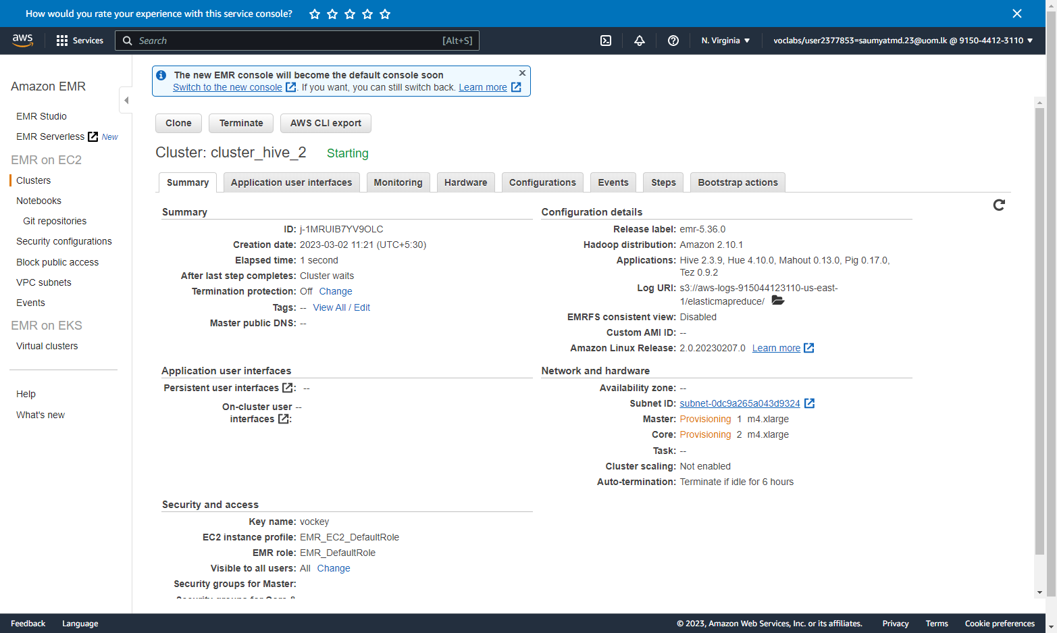

### Cluster started

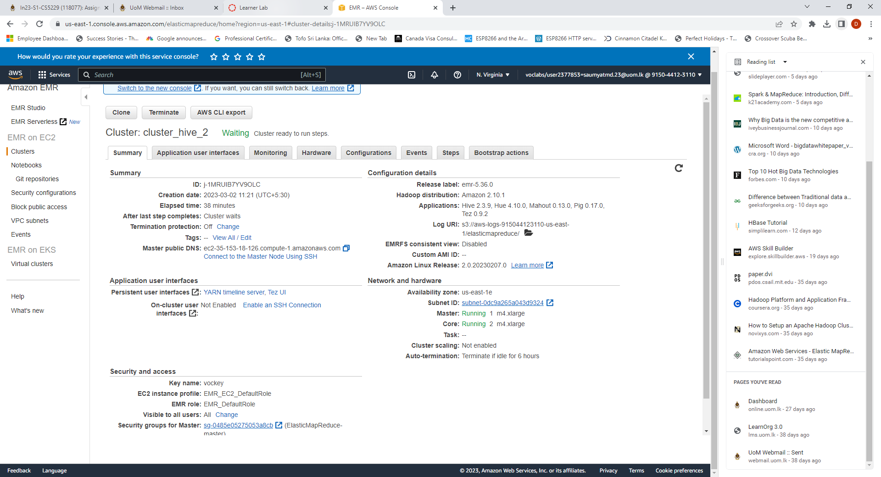

### Adding inbound rule to master rule

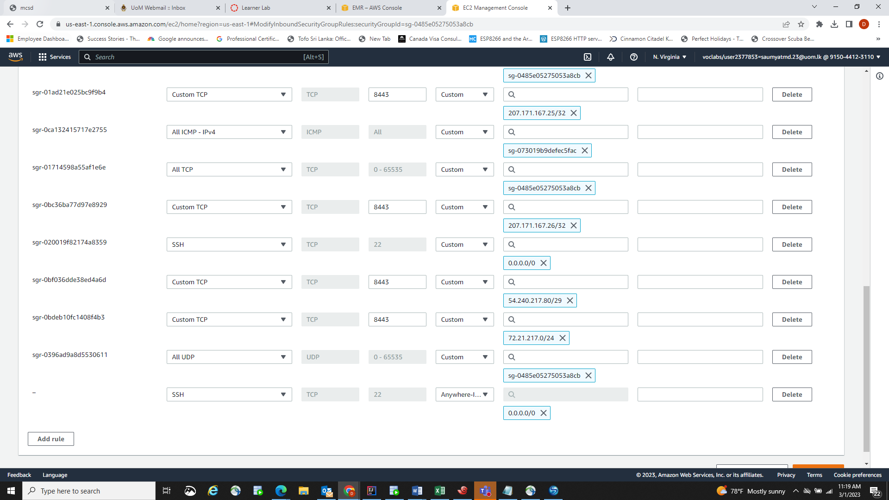

### Connecting to master node of the cluster using SSH connection using vockey key

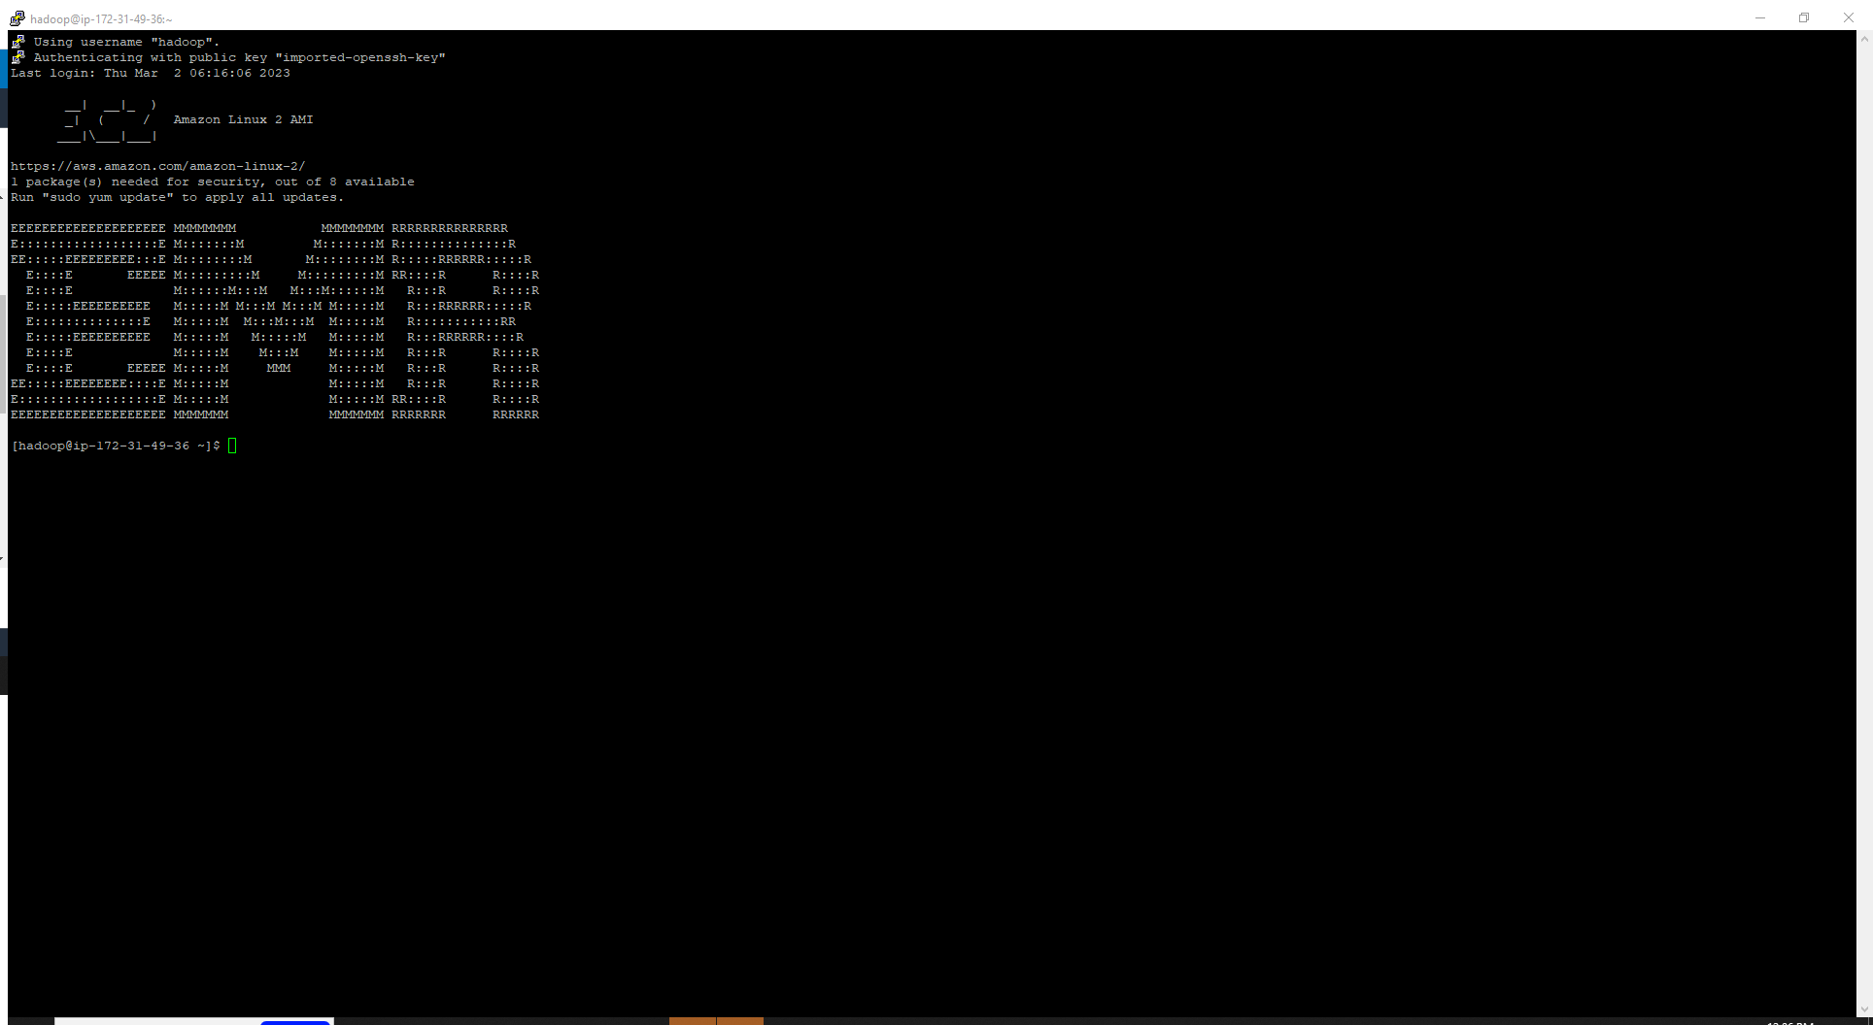

## S3 bucket creation

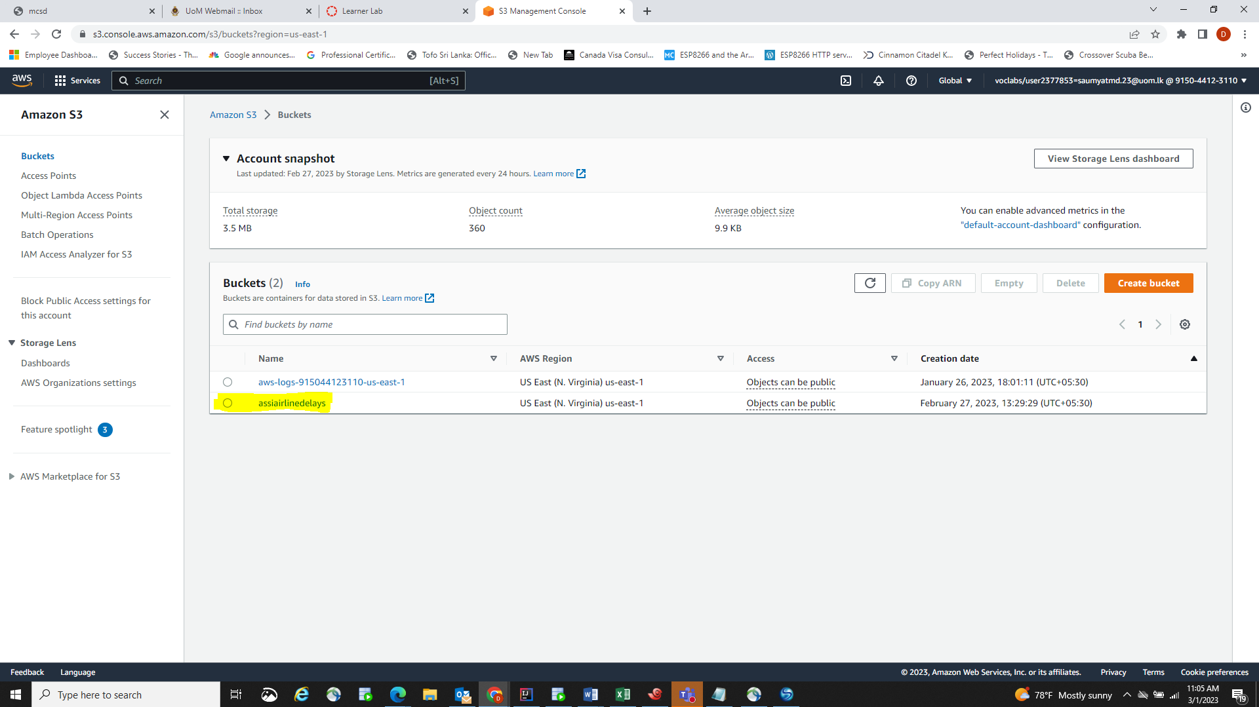

## Uploading data set to S3 bucket – input folder

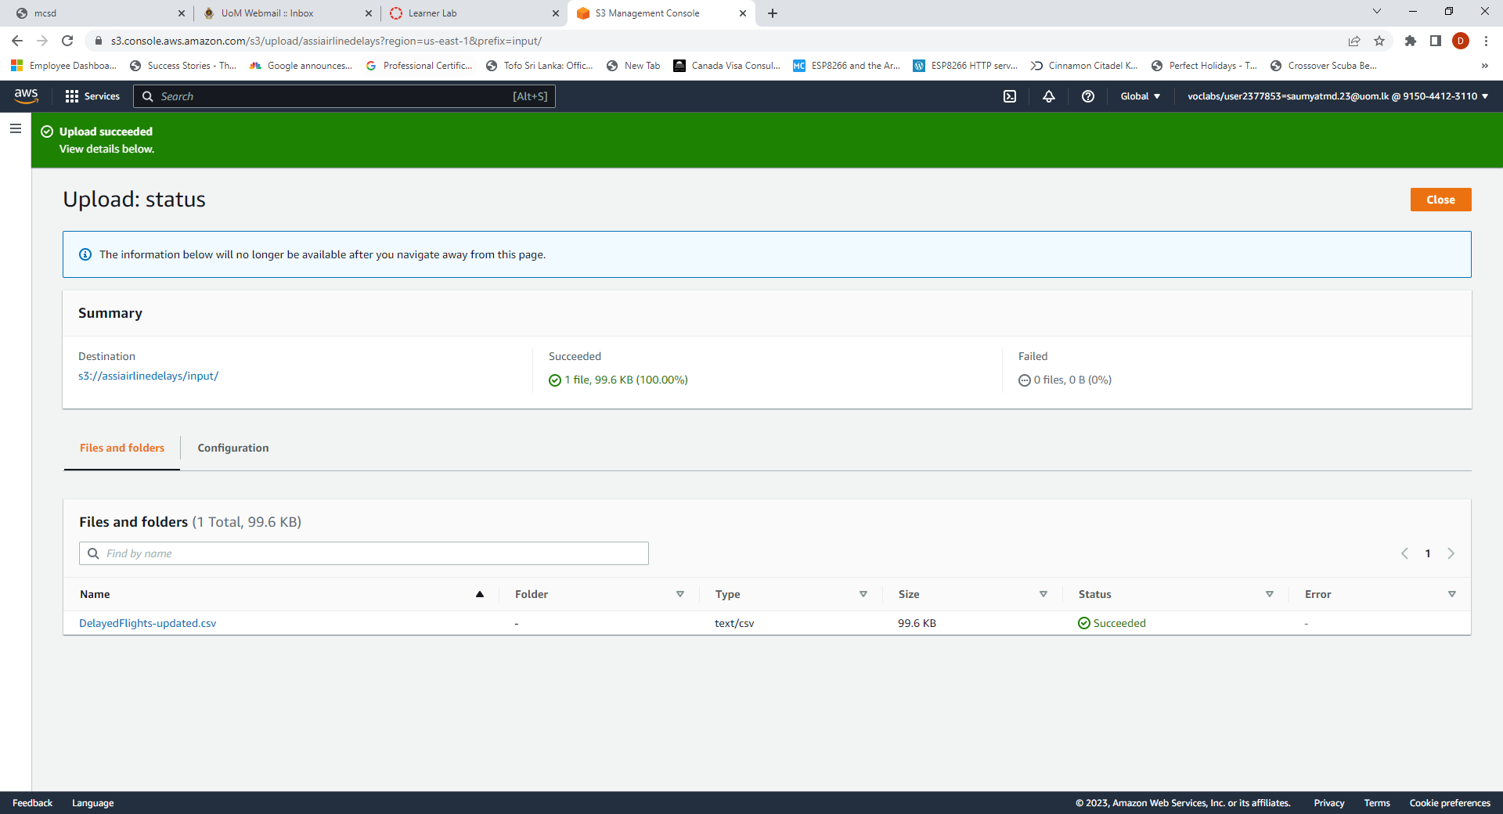

### Running hive command to see no of tables in the hive

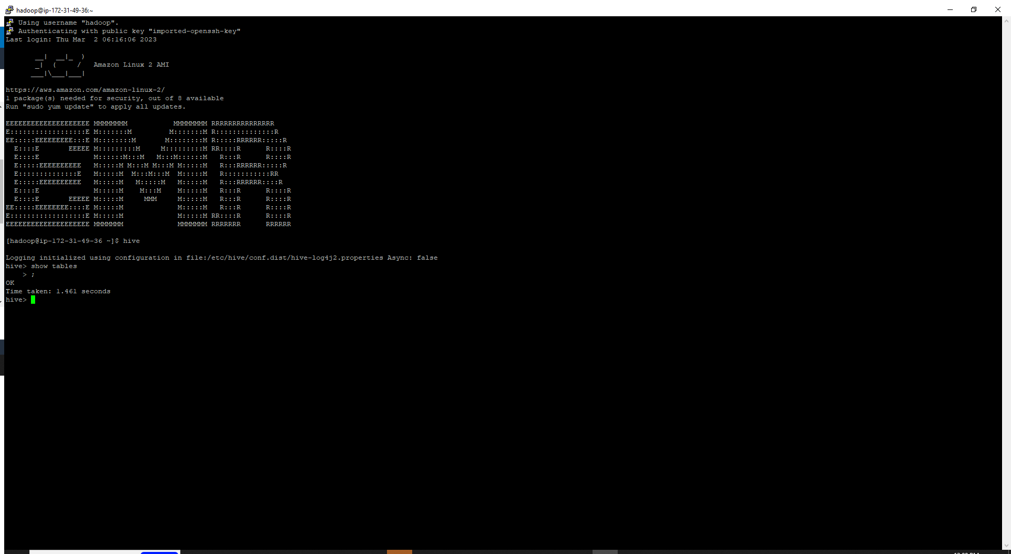

### Created local table using hive CREATE

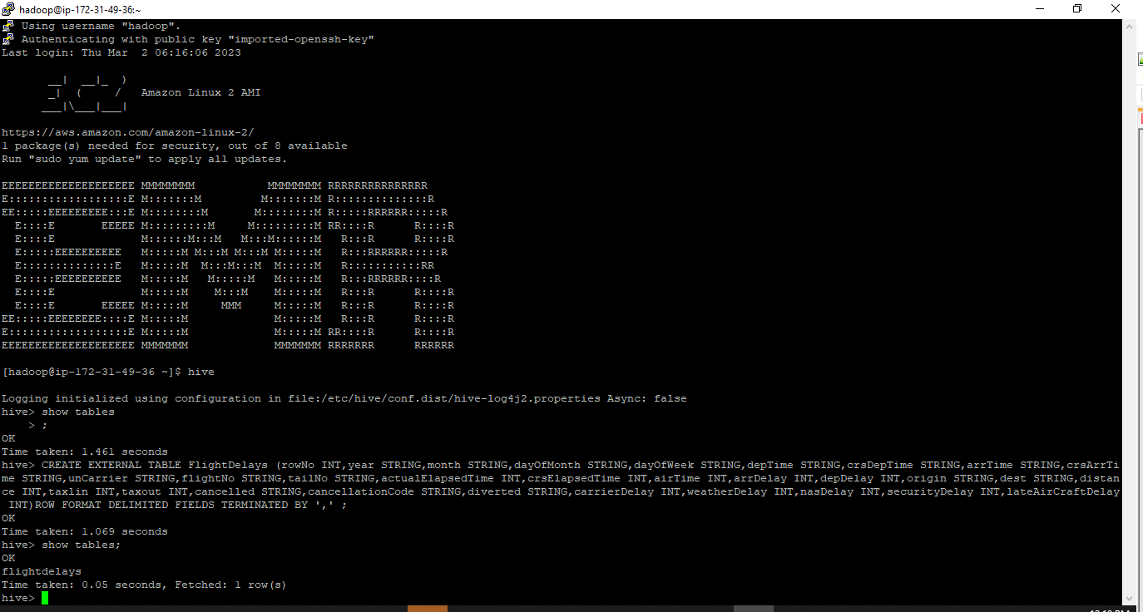

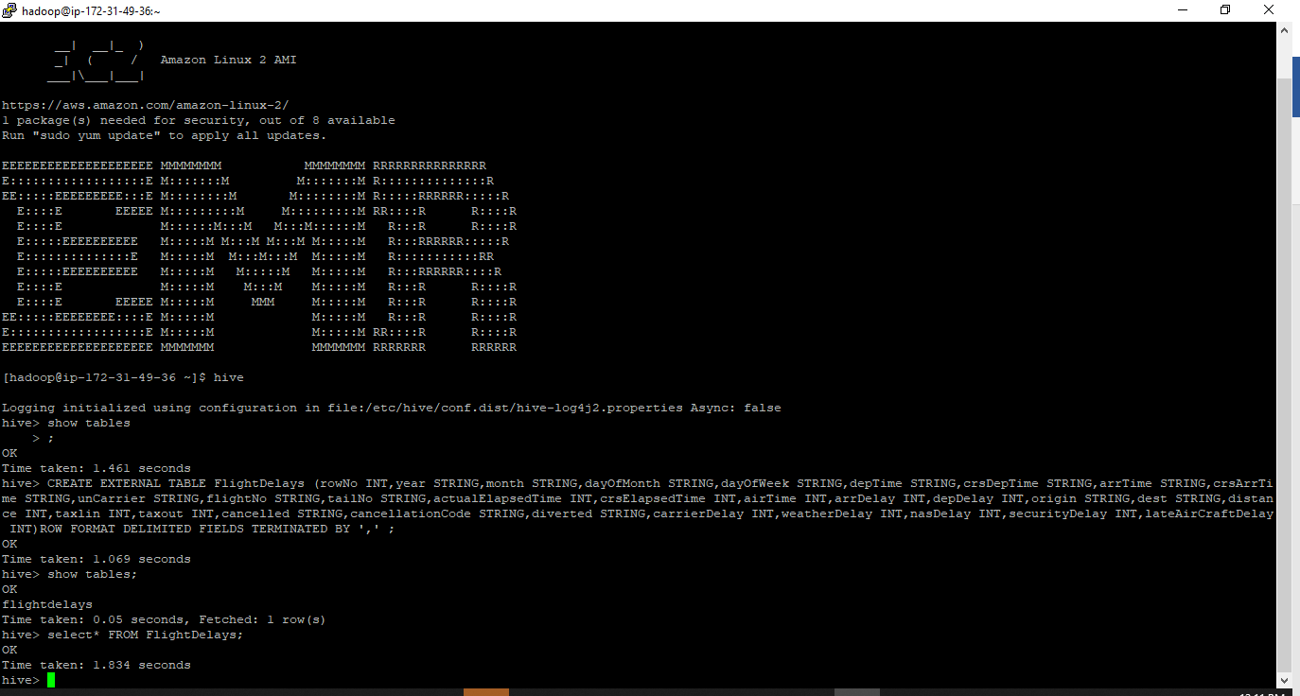

### Load the data and ran a select all query run on table

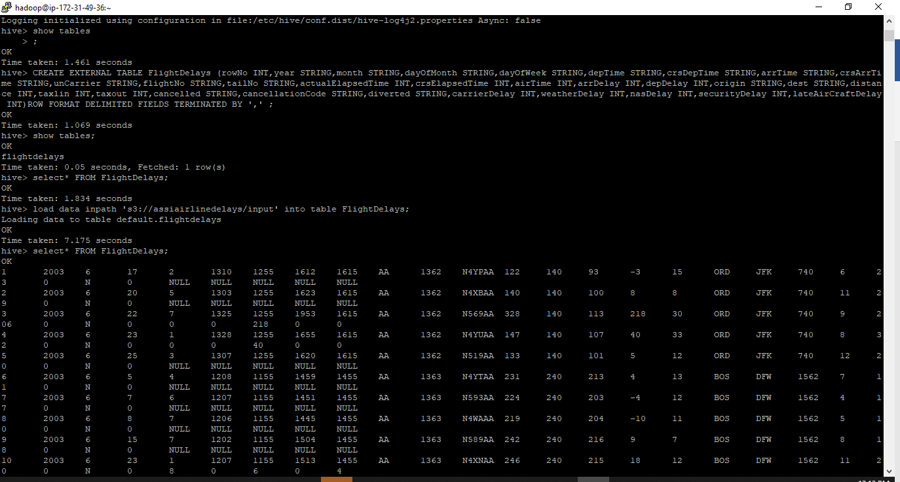

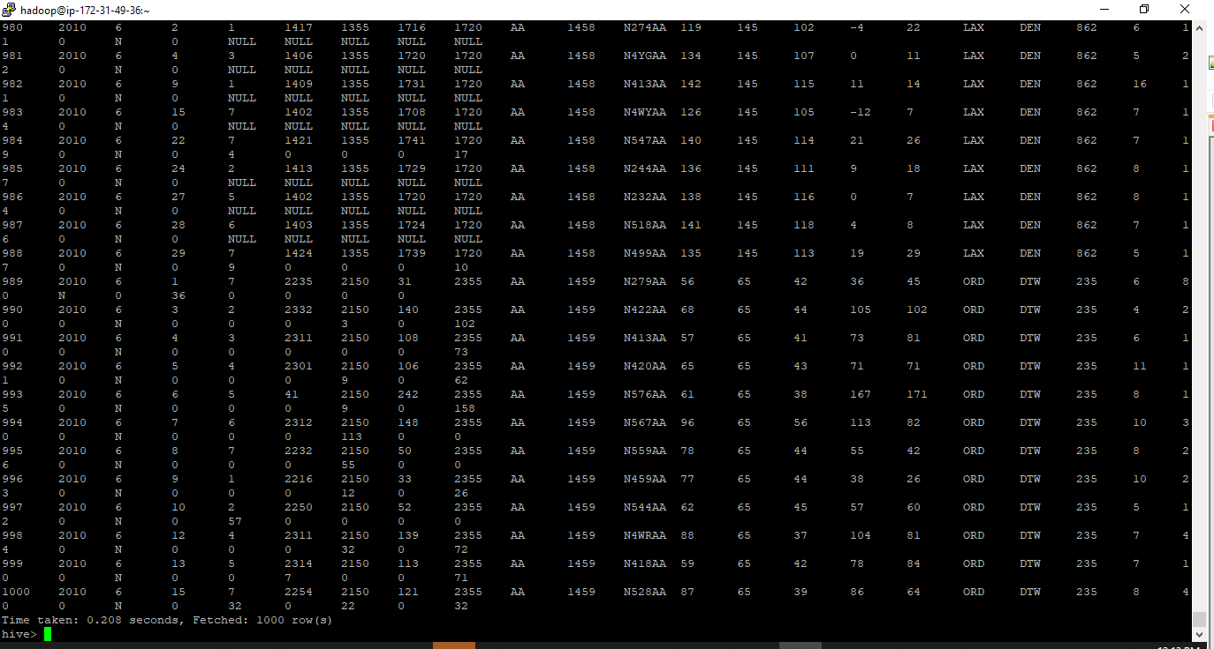

## Analysis of flight delays

### Year wise carrier delay from 2003-2010

#### Output

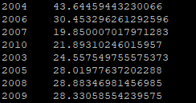

#### Iteration 1 -MR Jobs Summary

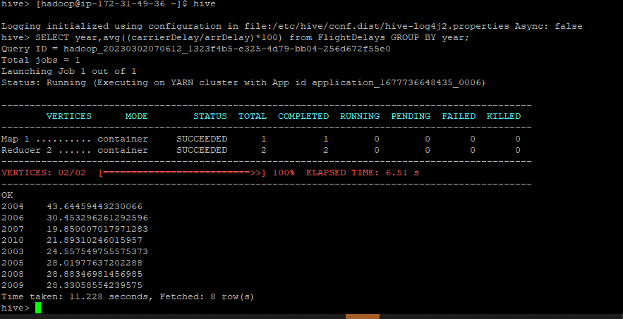

#### Iteration 2 -MR Jobs Summary

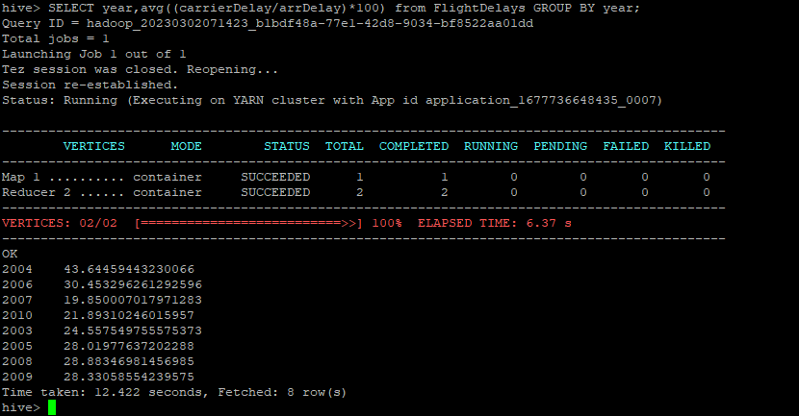

#### Iteration 3 -MR Jobs Summary

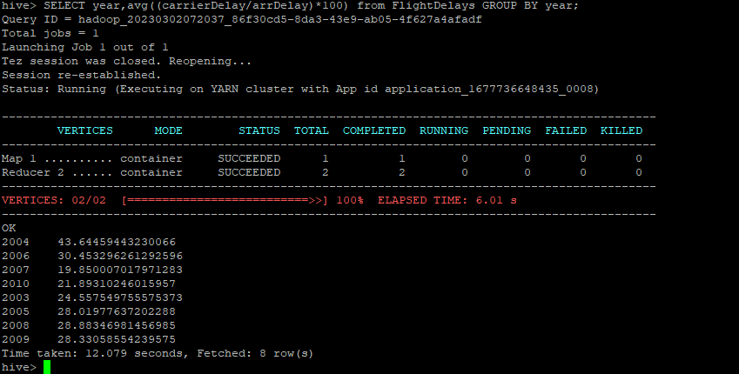

#### Iteration 4 - MR Jobs Summary

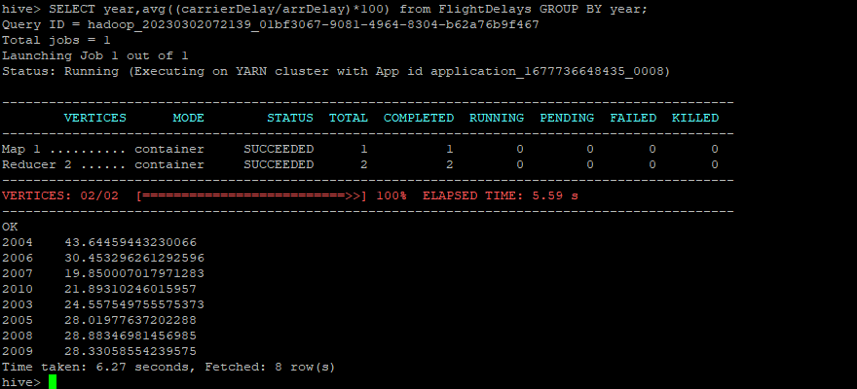

#### Iteration 5 - MR Jobs Summary

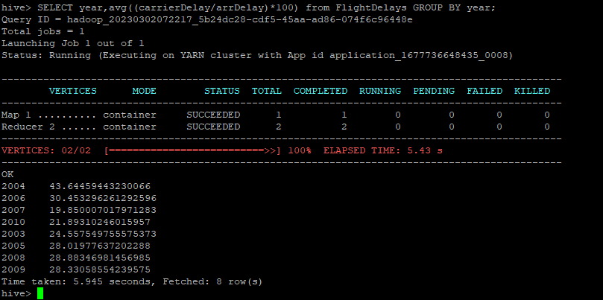

### Year wise NAS delay from 2003-2010

#### Output

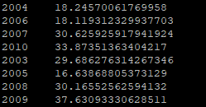

#### Iteration 1 - MR Jobs Summary

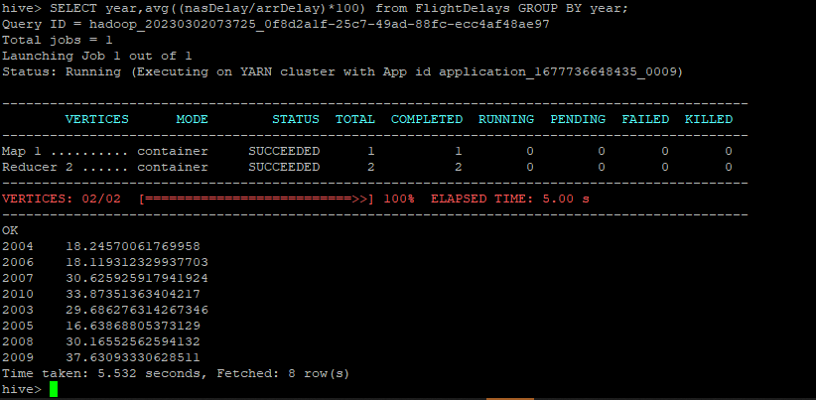

#### Iteration 2- MR Jobs Summary

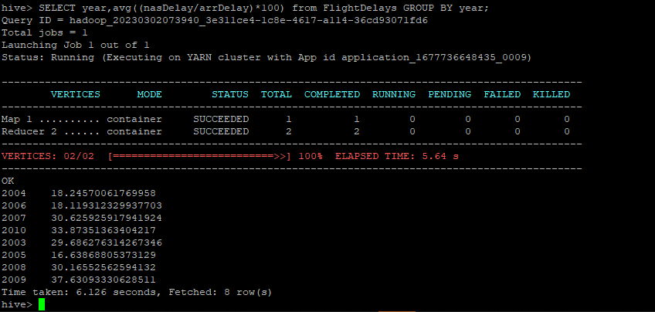

#### Iteration 3- MR Jobs Summary

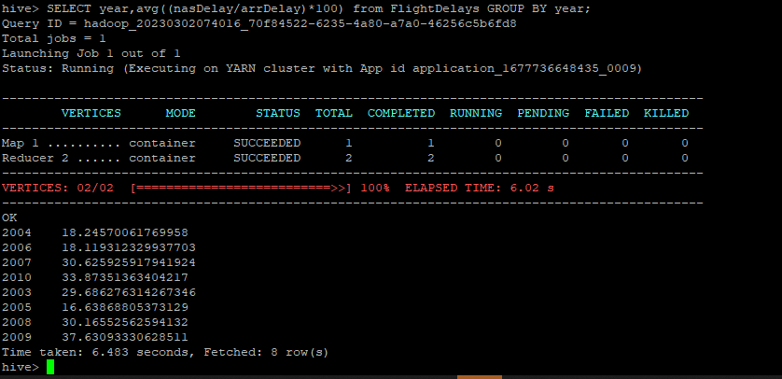

#### Iteration 4 -MR Jobs Summary

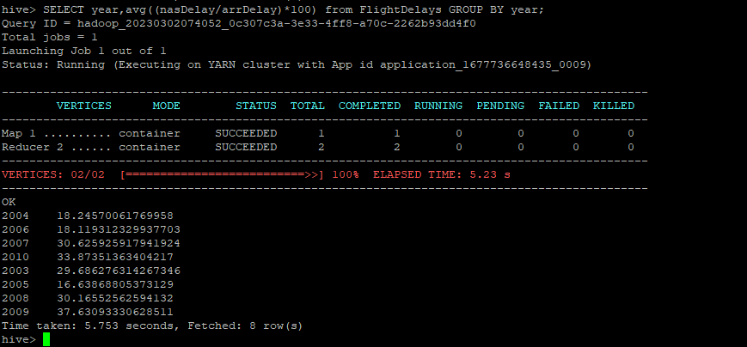

#### Iteration 5 - MR Jobs Summary

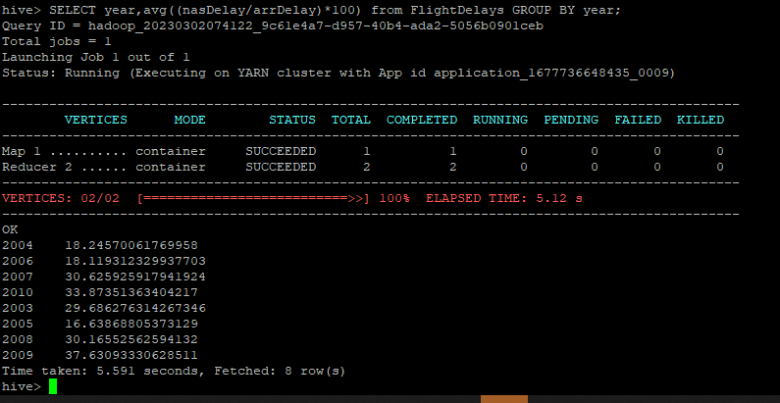

### Year wise Weather delay from 2003-2010

#### Output

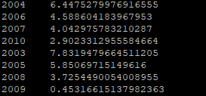

#### Iteration 1 - MR Jobs Summary

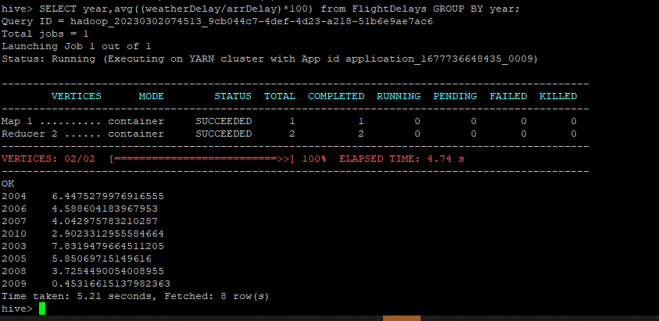

#### Iteration 2- MR Jobs Summary

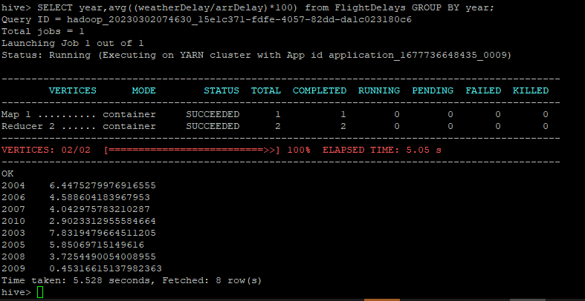

#### Iteration 3- MR Jobs Summary

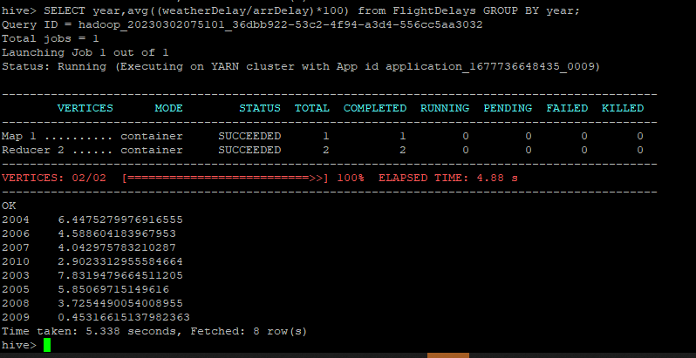

#### Iteration 4 -MR Jobs Summary

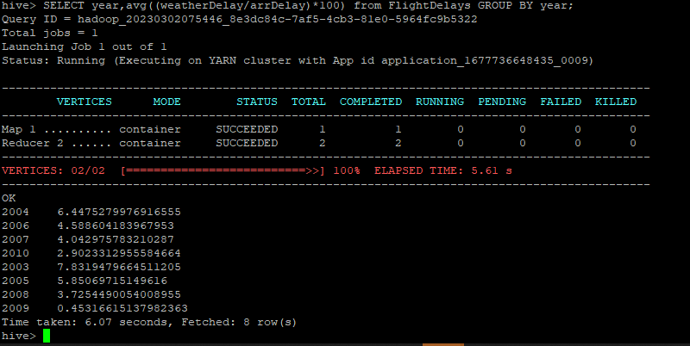

#### Iteration 5 - MR Jobs Summary

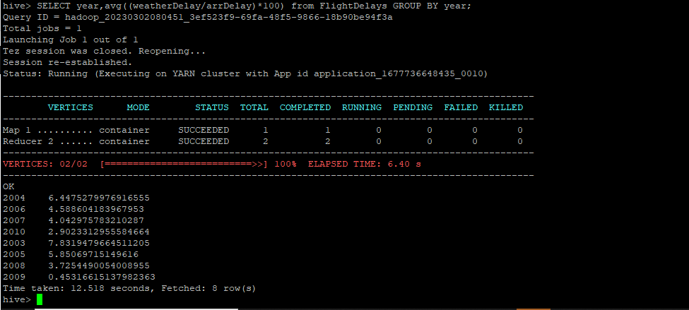

### Year wise late aircraft delay from 2003-2010

#### Output

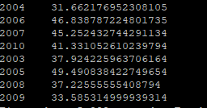

#### Iteration 1 - MR Jobs Summary

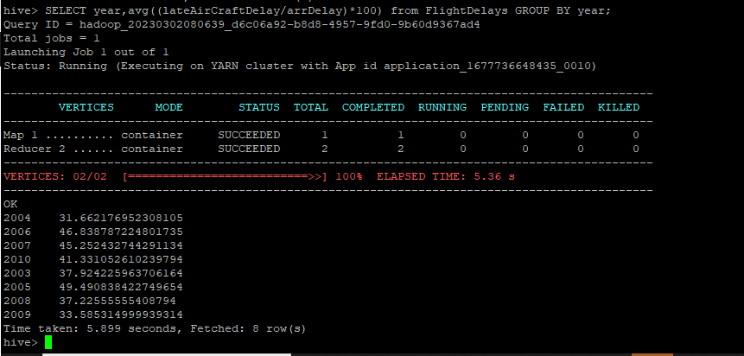

#### Iteration 2- MR Jobs Summary

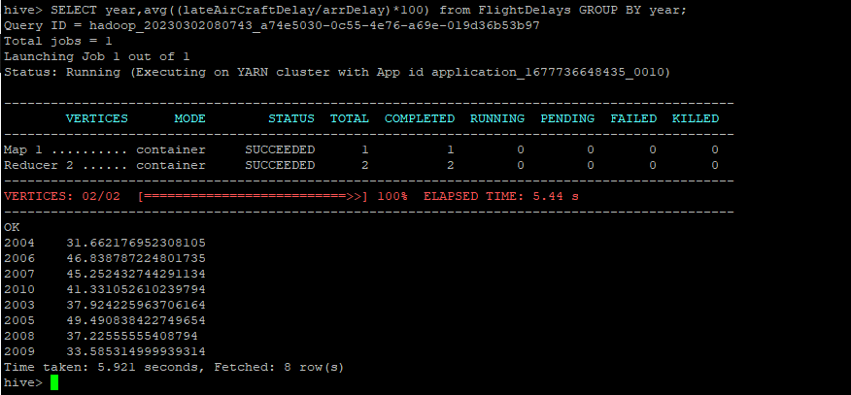

#### Iteration 3- MR Jobs Summary

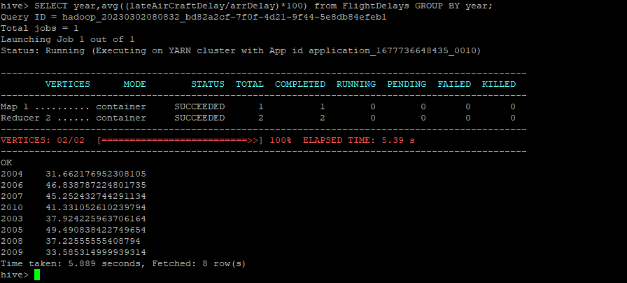

#### Iteration 4 -MR Jobs Summary

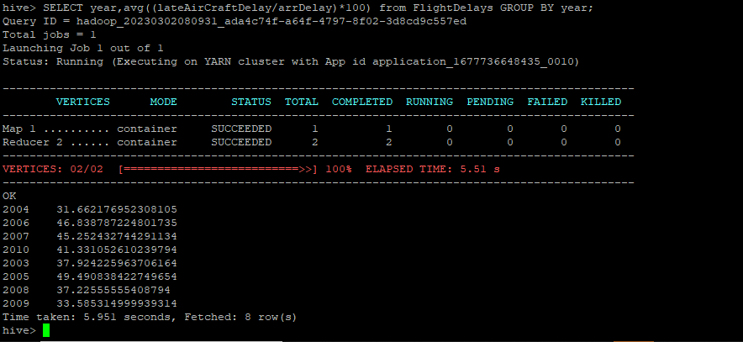

#### Iteration 5 - MR Jobs Summary

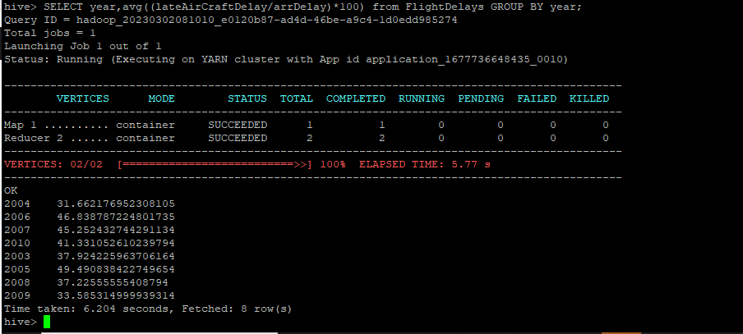

### Year wise security delay from 2003-2010

#### Output

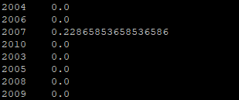

#### Iteration 1 - MR Jobs Summary

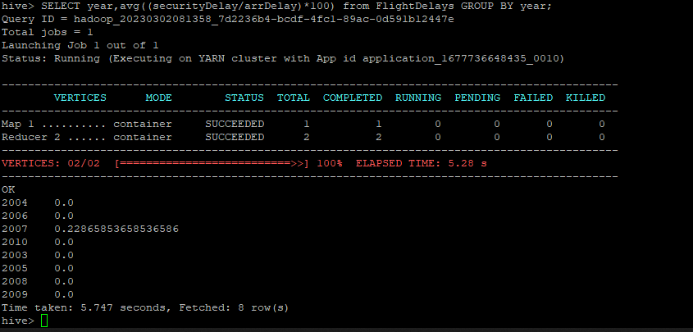

#### Iteration 2- MR Jobs Summary

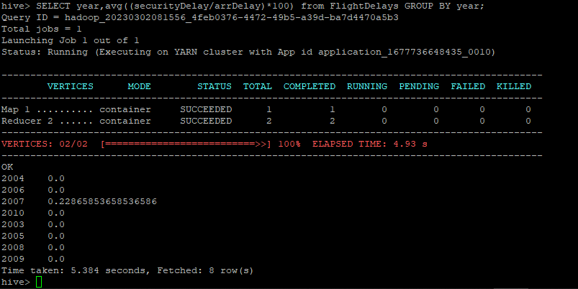

#### Iteration 3- MR Jobs Summary

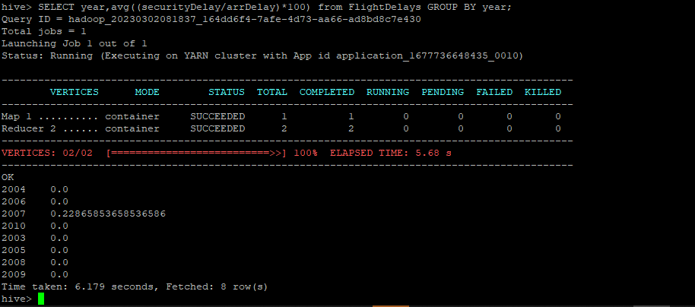

#### Iteration 4 -MR Jobs Summary

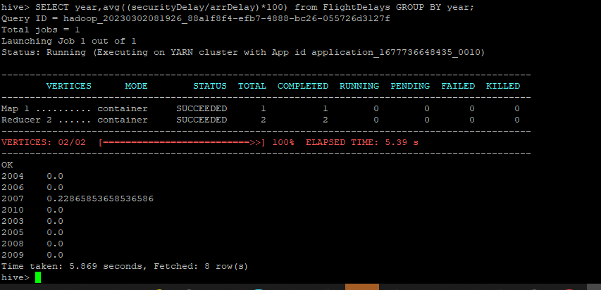

#### Iteration 5 - MR Jobs Summary

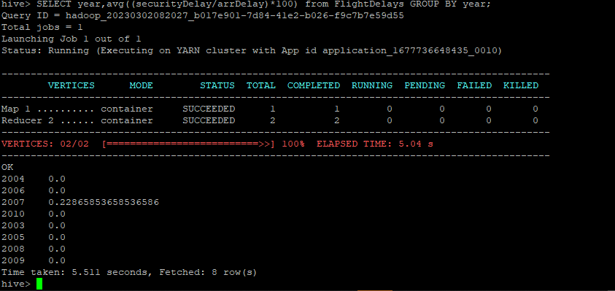

### Terminating the created cluster

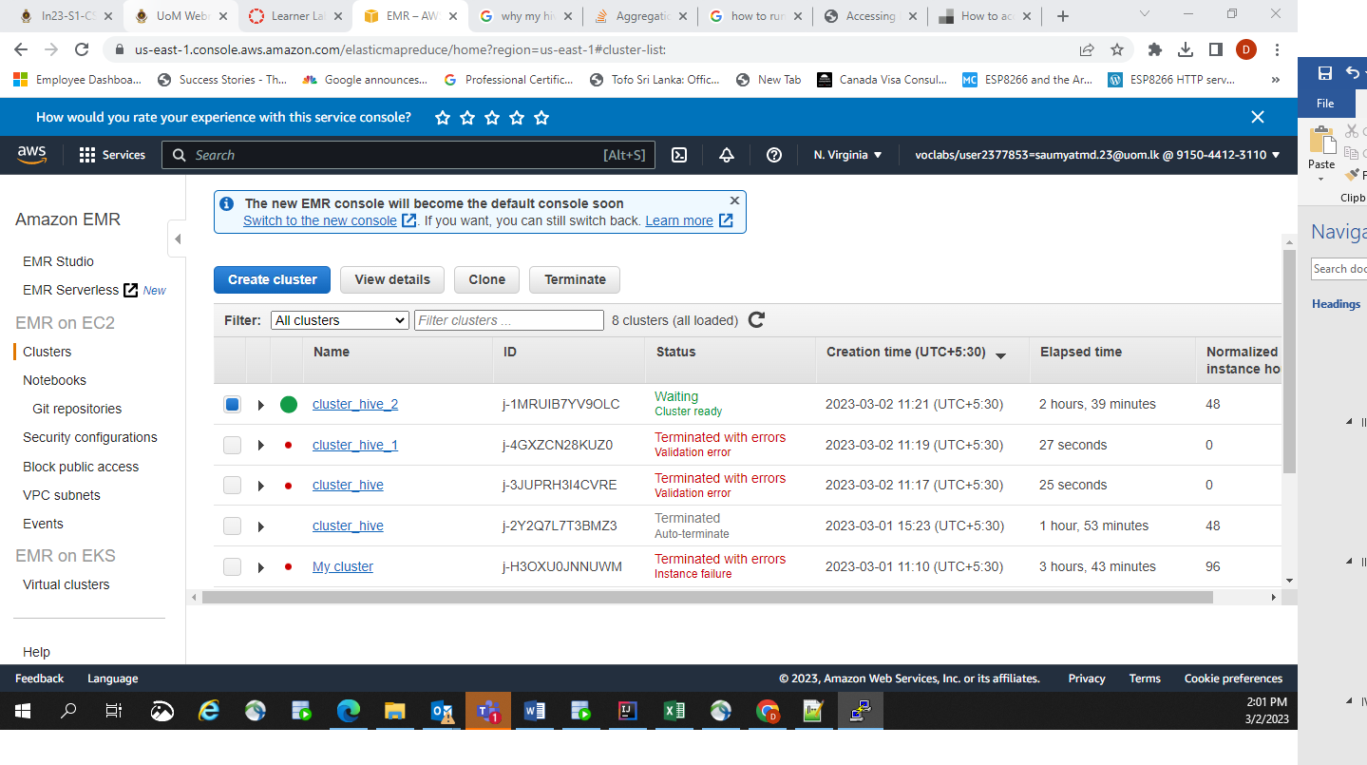

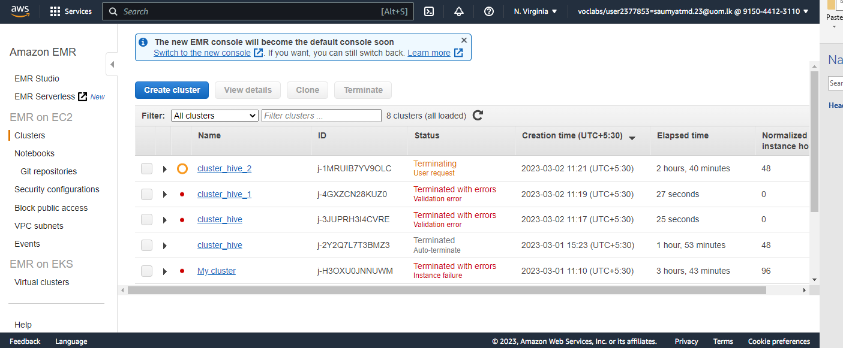

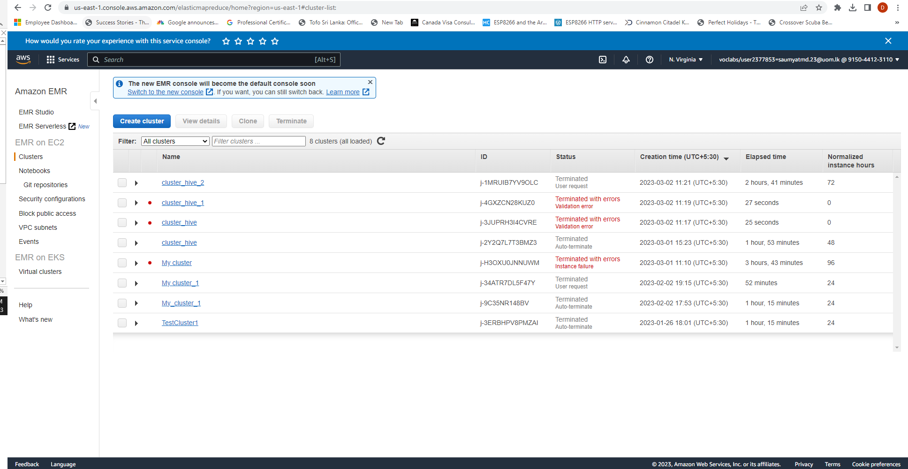

## E.  Hadoop and Spark for 5 times relates to each delay type

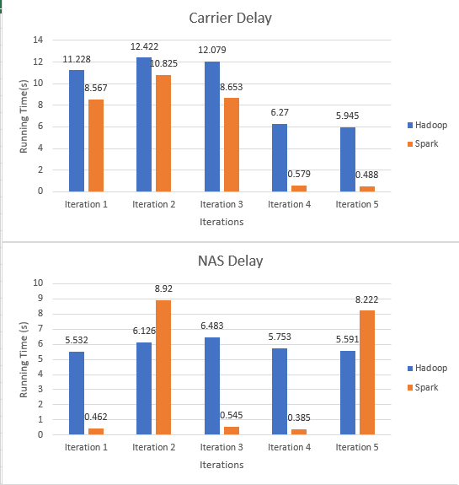

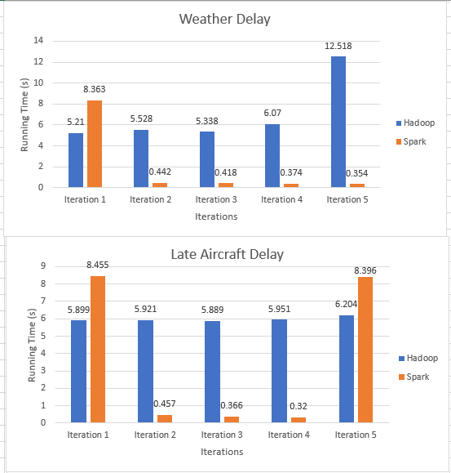

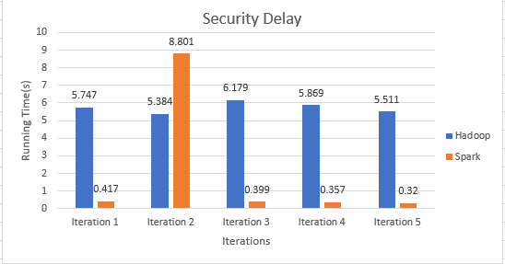

## F. Table below shows the comparison for all the queries with sample data for an iteration

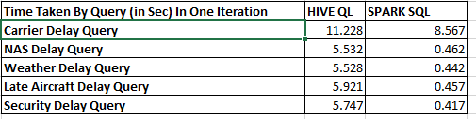

## G. Average time taken by MapReduce and Spark for each query

